
Name___________________________

Maths Specialist – Investigation 2019

Circle Geometry- Part One

Extended investigation Part 1: Preparation activity

Using the Geometry Application on the ClassPad

Tap  from the main menu to select the Geometry application.

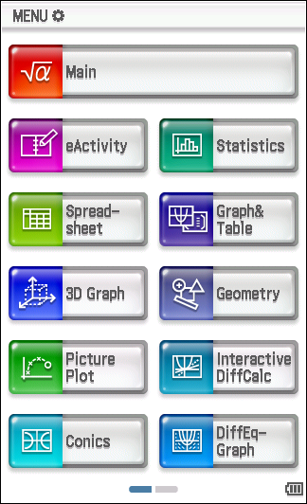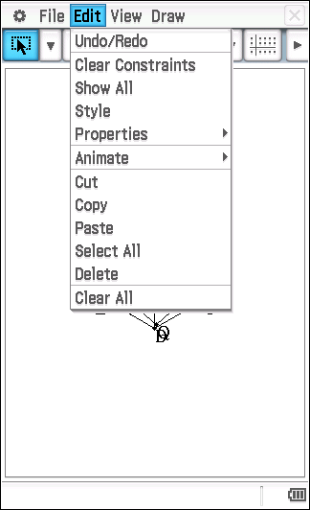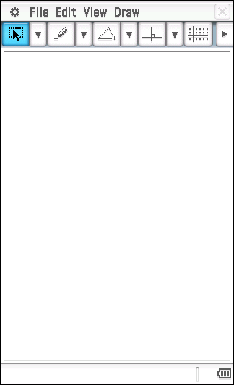

To clear the screen, tap Edit, tap Clear all.

Apply the following CAS settings for the Geometry application.

Tap O  Tap Geometry Format  Set Number Format to Fix 2  Set Measure Angle to Degree  Set Function Angle to Degree  Set Axes to Off  Tap Set | 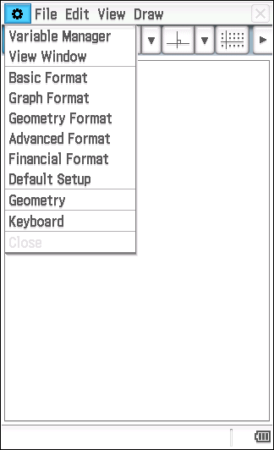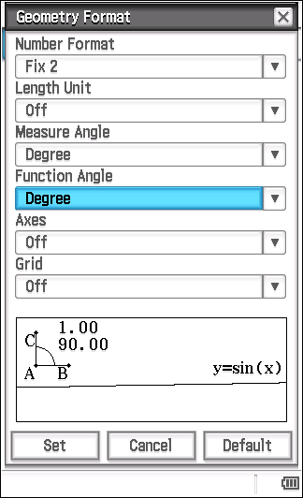

Tools available in the Geometry application

By tapping on the down arrow, C, to the right of each of the drop down menus,  [C PC pC  a number of tools become available.  When a tool is referred to, the accompanying screen picture shows where the tool may be found. | 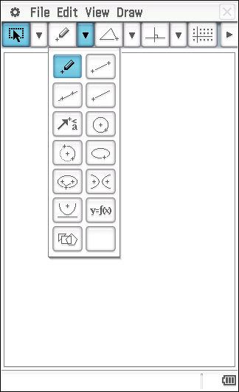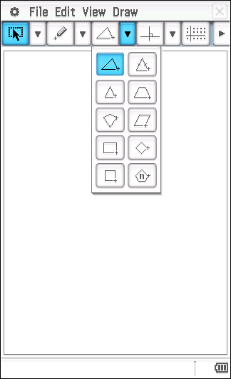  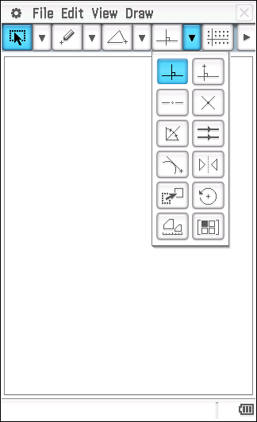

The Measurement Box

Tap u to display the Measurement Box.  Tap w to return to the normal toolbar. | 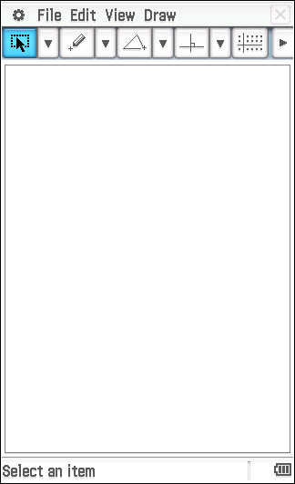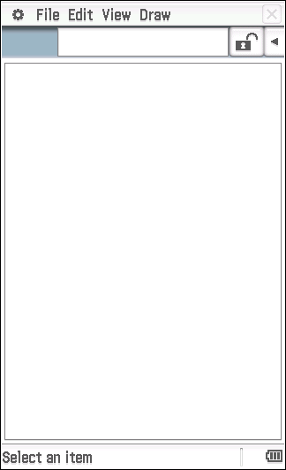  normal toolbar Measurement box

The Measurement Box can be used to perform operations such as:
- viewing measurements such as length, angle size
- to specify a measurement, e.g. set a length to represent a measurement of 12 cm or an angle to be of size 48°
- to name a point, line segment, angle, …
- to determine whether a line is tangential to a circle
- to fix a line so that it is tangential to a circle
NOTE:
- To deselect an object (or objects), tap G and then tap anywhere in space within the Geometry window.
- To undo tap Edit, tap Undo / Redo.
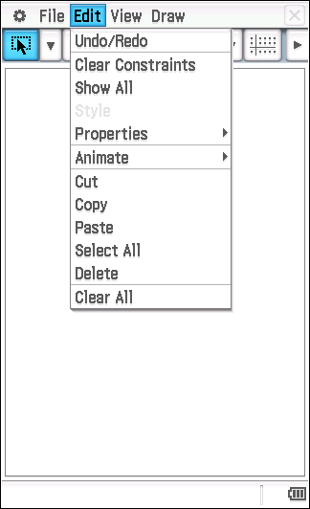
Question 1

Write a definition for each of following.

Central Angle:

Chord:

Cyclic quadrilateral:

Diameter:

Radius:

Major/Minor Arc:

Major/Minor Segment:

Alternate Segment:

Major/Minor Sector:

Secant:

Semicircle:

Tangent:

Question 2

Tap m.  Tap .  Tap File, tap New | 
Draw a circle by tapping U and then tapping in two different places in the Geometry window.  Tap View, tap Zoom to Fit. |  | 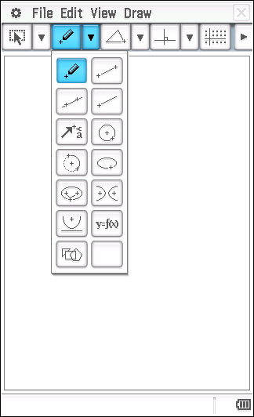
Draw a line passing through centre A and point B by tapping w, then tap A, tap B.  Tap G. |  | 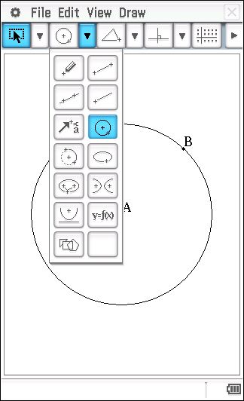
Select the circle and the line by tapping once on each of them.  Choose 7 to locate point D, the point of intersection of the circle and the line.  Draw diameter BD by tapping y, then tap B, tap D.  Tap G. |  | 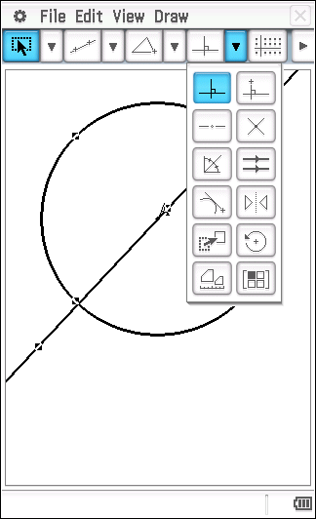
To hide the line passing through D, A and B, tap on any part of this line that lies outside the circle, tap Edit, tap Properties, tap Hide.  Tap [ and mark a point, E, on the circle.  Tap y to draw two chords, BE and DE.  You have now drawn triangle BDE where E is a point on the circle and DE is a diameter of the circle centre A,  Tap G. |  | 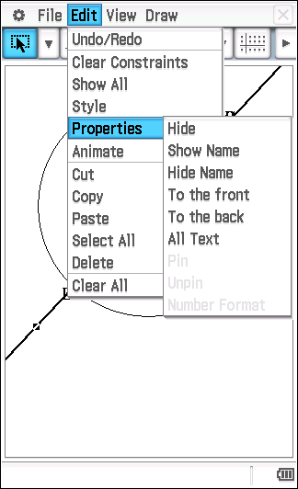
Tap u to display the Measurement Box.  Measure the size of ∠BED by tapping once on BE and once on DE. The angle size of ∠BED will be displayed in the measurement box.  Tap on the angle size of ∠BED displayed in the Measurement Box and drag it into the Geometry window.  Name this angle BED by tapping u and using the 0 tab on the keyboard to type BED, press =, press E.  Hide the keyboard.  Tap in space. |  | 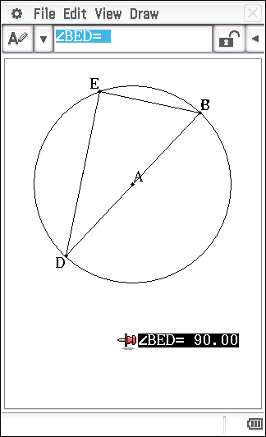
Observe the size of ∠BED as point E moves around the circle by using one of the two methods below:  Method One  Tap E, tap the circle.  Tap Edit, tap Animate, tap Add Animation.  Tap Edit, tap Animate, tap Go (once).  Method Two  Tap E, tap E a second time and drag it around the circle.  To save this file, tap File, tap Save and name the file Qn_2. |  | 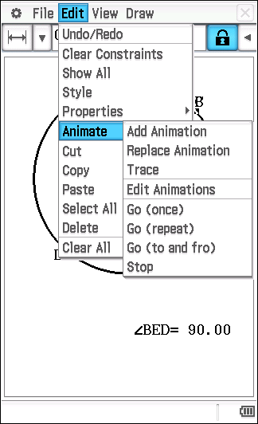

(a) Why do you think ∠BED is referred to as the angle in the semicircle?

(b) What do you notice about the size of ∠BED as point E moves around the circle?

(c) Make a conjecture about the size of the angle in a semicircle.

Conjecture: The angle in a semicircle is …

Question 3

A proof of your conjecture about the angle in a semicircle has been started for you. Complete the proof. Remember that statements in the proof need to be justified.

Angle in a Semicircle Theorem

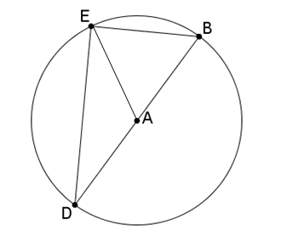

Given: Circle centre A, diameter BD. E is any point on the circle, ∠BED is an angle in the semicircle DBE.

To Prove:

Extension to
the diagram: Draw AE.

Proof:

Question 4

Tap m.  Tap .  Tap File, tap New |  | 
Draw a circle by tapping U and then tapping in two different places in the Geometry window.  Tap View, tap Zoom to Fit. |  |  | 
 | Tap [ and mark points, C and D, on the circle as shown in the diagram.  Tap y. Draw radii AC and AD; draw chords BC and BD.  Your diagram should show that ∠CBD is subtended at the circumference by arc CD in the same segment as ∠CAD (see diagram). Recall, points can be moved by tapping on the point once and then tapping a second time to drag to a new position. Don’t forget to tap in space to deselect before selecting a different item.  Tap G.  Tap u to display the Measurement Box. |  |  | 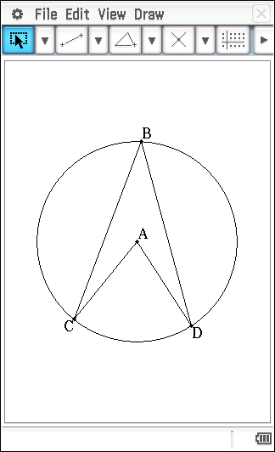
 | Display the size of ∠CBD by tapping BC and BD.  Tap on the size of ∠CBD and drag it into the Geometry window.  Name this angle CBD by tapping u and using the 0 tab on the keyboard to type CBD, press =. Press E.  Tap in space.  Display the size of ∠CAD by tapping AC and AD.  Tap on the size of ∠CAD and drag it into the Geometry window.  Name this angle CAD by tapping u and using the 0 tab on the keyboard to type CAD, press =. Press E.  Tap in space.  Hide the keyboard. |  |  | 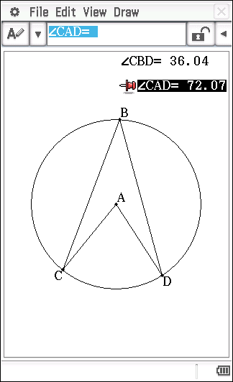
 | Observe the size of angles ∠CAD and ∠CBD when points C and D respectively move on the circle.  Tap C. Tap C a second time and drag it around the circumference such that ∠CAD and ∠CBD both remain in the same segment.  Tap in space.  Tap D. Tap D a second time and drag it around the circumference such that ∠CAD and ∠CBD both remain in the same segment.  To save this file, tap File, tap Save and name the file Qn_4. |  |  | 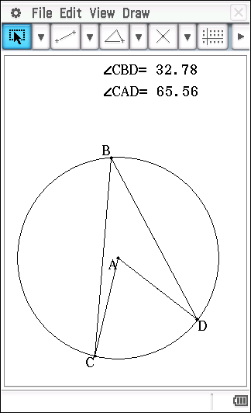

(a) By which arc are angles CBD and CAD both subtended?

(b) What do you notice about the size of the angle subtended at the centre of the circle, ∠CAD, and the size of the angle subtended at the circumference of the circle, ∠CBD?

(c) Make a conjecture about the size of the angle at the centre subtended by an arc of a circle and the size of the angle at the circumference subtended by the same arc.

Conjecture: The size of the angle at the centre subtended by an arc of the circle is …

Question 5

A proof of your conjecture about the central angle has been started for you. Complete the proof. Remember that statements in the proof need to be justified.

Central Angle Theorem
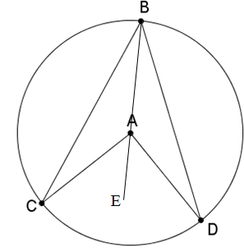
Given: Circle centre A. ∠CAD is the angle subtended by arc CD at the centre and ∠CBD is the angle subtended by arc CD at the circumference

To Prove:

Extension to
the diagram: Join BA and produce it to E.

Proof: Statement Reason

Question 6

Prove that two angles at the circumference subtended by the same arc are equal, i.e. .
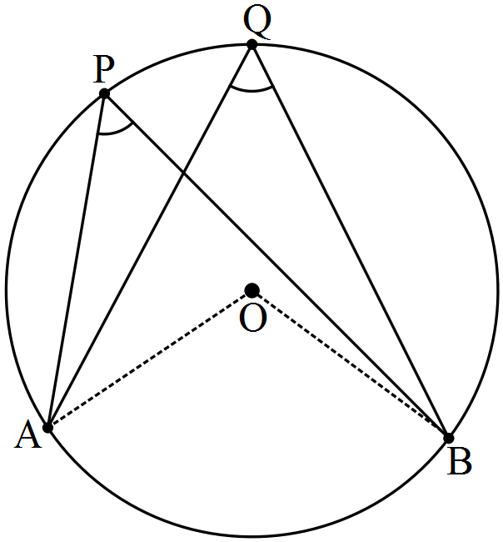
Question 7

Use the Geometry application to draw a circle centre A and radius AB. Mark points C and D on the circle as shown in the diagram below. Draw EC tangential to the circle at C by drawing a line through C. Tap u to display the Measurement Box. Tap on the line, tap on the circle. If No is displayed, tap b. EC is now tangential to the circle at C. Draw line segment EC and chords BD, CD and BC. ∠CBD is an angle in the alternate segment to ∠DCE.

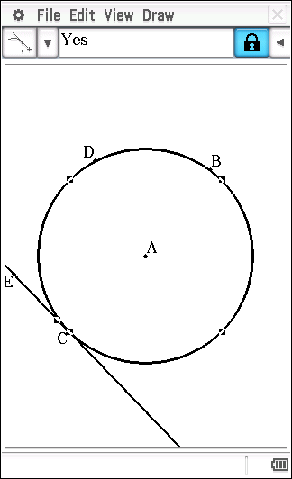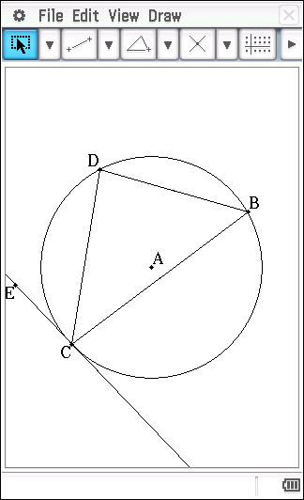

Note: it will be necessary to draw line segment EC prior to measuring the size of ∠DCE.

Save your file as Qn_6.

(a) Whilst maintaining the location of ∠CBD in the alternate segment to ∠DCE, move point D on the circle. What do you notice about the size of ∠CBD and the size of ∠DCE?

(b) Make a conjecture about the angles in the alternate segment.

Conjecture: An angle between a chord and a tangent is …

Question 8
Use the Geometry application to draw a circle centre A and radius AB. Position point C anywhere outside the circle and point D on the circle. Draw line segments CB and CD. Tap u to display the Measurement Box. Tap on CB, tap on the circle. If No is displayed, tap the tick, b. CB is now a tangent to the circle at B. In a similar manner, make CD a tangent to the circle at D.

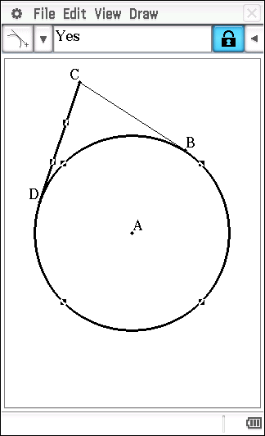

(a) What do you notice about the lengths of tangents CB and CD as you change the location of point C?

(b) Make a conjecture about the lengths of the tangents drawn from a point to a circle.

Question 9

Use the Geometry application to draw a circle centre A and radius AB. Use y to draw intersecting chords BC and DE. Select BC and DE, tap 7 to determine F, the point of intersection of chords BC and DE. Tap u to display the Measurement Box.
Display the length of chord BF by tapping on B and on F. Tap on the size of BF and drag it into the Geometry window. Label this chord length BF.

In a similar manner, display the length of chords CF, DF and EF.

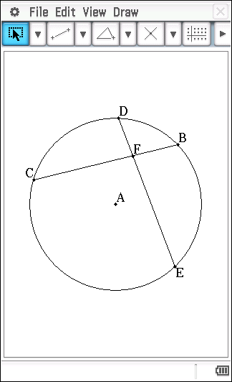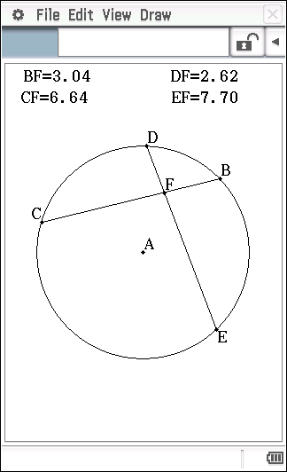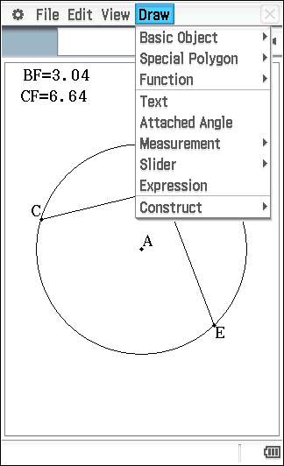
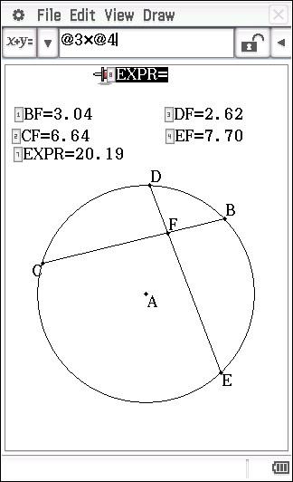
To calculate the product of BF and CF, tap Draw, tap Expression. Tap BF, press *, tap CF, press E. In a similar manner, display the product of DF and EF.

(a) What do you notice about BF x CF and DF x EF as you change the locations of C, D, E and F?

(b) Make a conjecture about the product of the lengths of the intervals on one chord and the product of the lengths of the intervals of an intersecting chord.

Question 10

(a) AB, AC and BC are tangents; AB = 15 cm; BC = 17 cm; BP = 9 cm. Find AC.

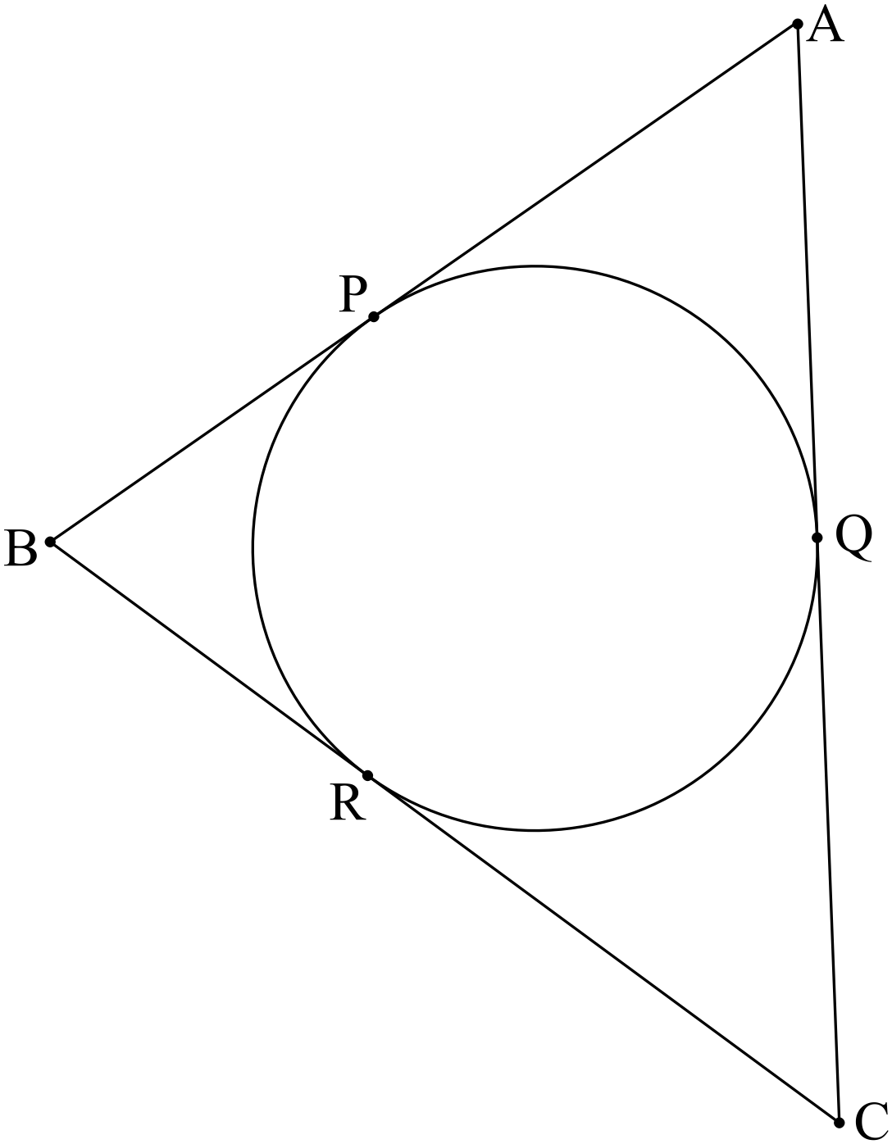

(b) AB and AC are tangents; . Find the size of

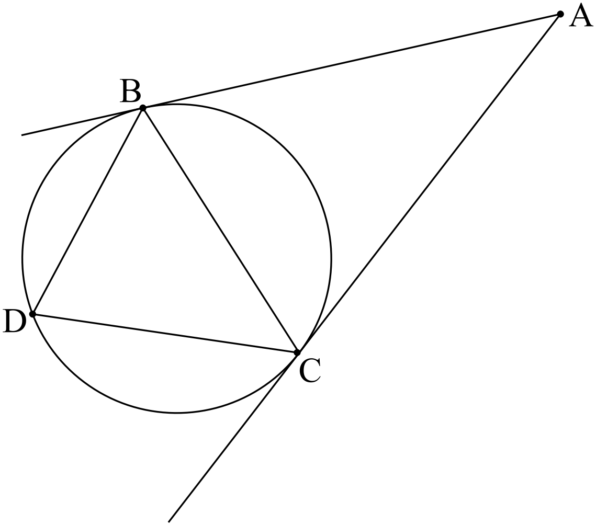

(c) PE is a tangent; AD is parallel to PC; . Find the size and .

